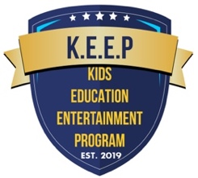

Kids Education Entertainment Program Inc
848 Oglethorpe Ave #115479
(470) 900-6575 • Main Email: info@keep-inc.org
EIN: 84-2654259 • Website: www.keep-inc.org

